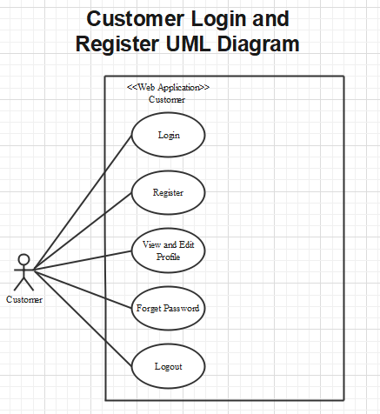

**Customer**

**Login as customer:**

|  |  |  |
| --- | --- | --- |
| **Author** |  | |
| **Use Case Name** | Login | |
| **Actors** | Customer | |
| **Description** | Customer who has registered an account can login | |
| **Requirements** | Customer provides username and password | |
| **Pre-conditions** | Customer must register an account | |
| **Post-conditions** | Success: Customer is logged in to website | |
| Fail: Refill information | |
| **Basic flow** | **Actor’s actions:** | **System’s responses:** |
| 1. Customer clicks ‘Login’ button on Home Page.  3. Actor inputs Email and Password, then click the ‘Login’ button. | 2. System redirects to Login Page with the following controls:  - “Email” text field  - “Password” text field  - “Login” button  4. System checks the information.  5. System redirects to Customer’s dashboard. |
| **Exceptions** | **Actor’s actions:** | **System’s responses:** |
| 1. Actor inputs invalid email and password. | System redirects to Login page with the following controls:  - “Email” text field  - “Password” text field  - “Login” button  System shows message: “Invalid email and password”. |

**Register as customer:**

|  |  |  |
| --- | --- | --- |
| **Author** |  | |
| **Use Case Name** | Register as Customer | |
| **Actors** | Customer | |
| **Description** | Customer who has registered an account can login | |
| **Requirements** | Customer registers an account on the website and becomes a member | |
| **Pre-conditions** | Customer provides their register information | |
| **Post-conditions** | Success: Customer creates a User account in this website | |
| Fail: Refill information | |
| **Basic flow** | **Actor’s actions:** | **System’s responses:** |
| 1. Customer clicks “Register” button on Home Page.  3. Customer inputs register’s information and click “Register” button. | 2. System redirects to Register page and displays Registration form with the following controls:  - “Username” text field  - “Password” text field  - “Confirm Password” text field  - “Email” text field  - “Phone” text field  - “Register” button  - “Reset” button  4. System validates the information.  5. System inserts the account into database  6. System show success message. |
| **Exceptions** | **Actor’s actions:** | **System’s responses:** |
| - Actor left “Username” text field blank.  - Username has already existed.  - Actor left “Password” text field blank.  - Actor left “Confirm Password” text field blank.  - Password and confirm password don’t match.  - Actor left “Email” text field blank.  - Email has already existed.  - Actor left “Phone” text field blank.  - Input phone is not numeric format or phone length is not between 8 and 14 characters.  - Actor left “Email” text field blank or input an invalid email address. | System displays message to customer:  - “Username cannot be blank”.  - “This Username has already existed”.  - “Password cannot be blank”.  - “Confirm Password cannot be blank”.  - “Confirm Password does not match password.”.  - “Email cannot be blank”.  - “This Email has already existed”.  - “Phone cannot be blank”.  - “The phone number should be numeric only and must be between 8 and 14 digits”.  - “Email is invalid”. |

**Forgot password:**

|  |  |  |
| --- | --- | --- |
| **Author** |  | |
| **Use Case Name** | Forgot password | |
| **Actors** | Customer | |
| **Description** | Customer who has forgotten password can make a request to change password | |
| **Requirements** | Customer provides email address | |
| **Pre-conditions** | Customer must be logged on | |
| **Post-conditions** | Success: Actor can change their password | |
| Fail: Refill information | |
| **Basic flow** | **Actor’s actions:** | **System’s responses:** |
| 1. Actor clicks on “Forgot Password” button.  3. Actor inputs Email and clicks “Submit”.  5. Actor inputs reset token in Password Page and click “Submit”.  7. Actor inputs new password and click “Save”. | 2. System redirects to Password Page with the following controls:  - “Email” text field  - “Submit” button  4. System checks the information and sends a reset token to user.  6. System redirects to Password form with the following controls:  - “New Password” text field  - “Confirm Password” text field  - “Save” button  8. System validates password then updates password in database.  9. System shows message: “Your password has been changed successfully”. |
| **Exceptions** | **Actor’s actions:** | **System’s responses:** |
| 1. Actor inputs an email which does not exist in database. | System shows message: “Invalid email”. |

**Edit profile:**

|  |  |  |
| --- | --- | --- |
| **Author** |  | |
| **Use Case Name** | Edit profile | |
| **Actors** | Customer | |
| **Description** | Customer who want to update their profile | |
| **Requirements** | Customer provides their personal information | |
| **Pre-conditions** | 1. Customer is logged in | |
| **Post-conditions** | Success: Actor can edit their profile | |
| Fail: Refill information | |
| **Basic flow** | **Actor’s actions:** | **System’s responses:** |
| 1. Actor clicks “Account” button on Home Page.  3. Actor inputs personal information and clicks “Submit”. | 2. System redirects to Account page and displays Account form with the following controls:  - “Fullname” text field  - “Address” text field  - “Email” text field  - “Phone” text field  - “Birthday” text field  - “Gender” text field  - “Submit” button  4. System validates password then sends to database.  5. System shows message: “Your account has been update successfully”. |
| **Exceptions** | **Actor’s actions:** | **System’s responses:** |
| 1. Actor loggin an account which does not exist in database. | System shows message: “Invalid account”. |

**Logout:**

|  |  |  |
| --- | --- | --- |
| **Author** |  | |
| **Use Case Name** | Logout | |
| **Actors** | Customer | |
| **Description** | Customer clicks on “Logout” button and their session is terminated. | |
| **Requirements** | N/A | |
| **Pre-conditions** | 1. Customer is logged in  2. Customer no longer wants to be logged in | |
| **Post-conditions** | Success: Customer can logout | |
| Fail: Refill information | |
| **Basic flow** | **Actor’s actions:** | **System’s responses:** |
| 1. Actor clicks “Log out” button on Home Page. | 2. The system logs the actor out and invalidates the session.  3. The system redirects to the default logout page. |
| **Exceptions** | **Actor’s actions:** | **System’s responses:** |
| 1. Actor can not logout | System shows message: “Not logged in”. |